- Form styling is not reliably supported

- Don't try to directly style the form element, it does not respond well

- Avoid styling browser form controls if possible.

- The best option is to create your own controls with images and javascript

- To get rid of the space created by the form element, give it a display value of inline

Style for control type input





**FLOAT**

float: right | left | none;

clear: right | left | none | both;

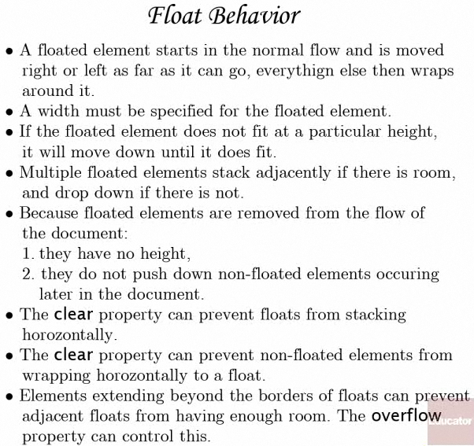

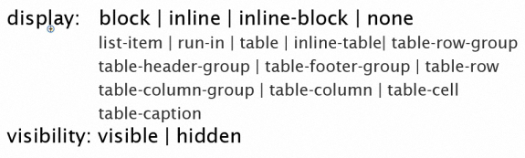

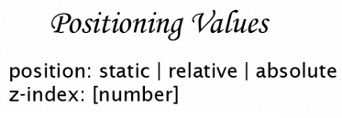

The default is position:static

//using id in div

#inner1

{

position**: relative**;

top 10px;

left 50px;

}

//using id in div

#inner2

{

position: **absolute**;

top 10px;

left 50px;

}

